Employee Resource Planning Software

- Requirement Gathering
- Pending/ Approval Needed

- API Design
- POST api/project/create_project
- GET api/project/get_project_details
- PUT api/project/update_project_details
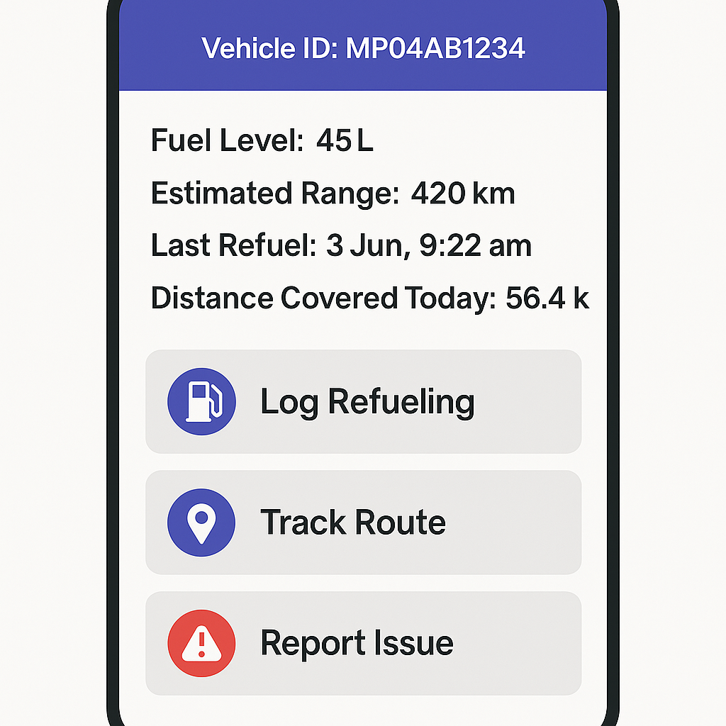

- POST api/machine/log_refueling
- POST api/machine/add_machine
- GET api/machine/get_machine_details (from gps sensors)
- POST api/machine/report_issue

- POST api/material/add_dumped_material
- POST api/material/add_material_usage
- GET api/material/get_material_details
- POST api/material/purchase_alert (for payment Manager)
- POST api/material/purchase_approval (request+approvals)
- POST api/material/generate_order (purchase successful, dispatched, delivered at site)

- POST api/user/add_user ✔️
- GET api/user/get_user_details ✔️
- POST api/user/attendance

- Deployment
- AWS EC2 – Pending, for 24/7 server uptime
- Domain – Pending, for Search Engine Visibility
- Publish to Play store – Pending

- Testing/ User Feedback
- Pending

